Reflection Work Creative Technology

**Anna Bezani**

*Thursday 3 November 2016*

# Week One

Monday 10th of October, the new module called Creative Technology started at 9.00 am and I will be honest within the first couple of hours I felt confused and terrified. For the first time in my life, I heard about the open source Arduino. During the following days everything became clearer. Professor Martin Skelly and Jon Rogers were really supportive, helping each of us individually and showing us that Arduino is easier than we first thought. It was inspiring to see how passionate they were in the studio, highlighting to us the wonder of Arduino.

The first assignment was to develop different ideas about a connected home. From these ideas, we had to choose one as our last final product due at the end of the fourth week.

I spent some time brainstorming and started to understand how the Arduino software worked. In this week, I developed three basic ideas, which could be used to help people. The first one was a product that alerted people when their pasta was al dente and ready to serve, as all too often people over do their pasta. Having analysed my idea, I thought that this wasn’t demonstrating how creative or innovative I could be. It didn’t represent me, and my wish to combine technology with helping people. This led me to think of the idea that I called “Magic Pillow”.

Magic Pillow was a product that could help autistic people. The main idea was to support them in waking up without feeling anxious or angry. Autistic individuals tend to be more sensitive to loud disruptive noises, such as alarm clocks. As a result I combined, using Arduino technology, a specific calm noise and vibration that could be used as an alarm. This idea consequently led me to think about the different ways that individuals with a disability require different things from their home. I thought about how best to support the needs of an individual through a connected home that would not be found on the market.

I found that research in supportive methods for those with a disability was quite scarce, especially for less common disabilities such as sever dyspraxia. I then decided that this was the area that I wanted to concentrate in. After sharing my idea with Professor John Rogers, he helped me be more accurate and showed me a new way of combining Arduino and Bare Conductive. This simplified my idea and gave it more of a practical application for improving the quality of life as well as day-to-day living.

Additionally, sharing ideas with PhD students gave more knowledge and focus on developing my idea.

After the end of the week, I developed greater skills in Arduino, which I can now add to my repertoire of computing skills. On reflection, I understand how my levels of stress at the beginning of the week impacted my creativity as I lost precious time. Understanding my stress better would have enabled me to create better ideas earlier in the week.

# Week Two

After the first week’s introduction and first encounter with Arduino, the pieces of technology, prototypes and connected home started to make more sense. Our goal during the second week was to develop three new ideas, where by one would be chosen to develop further as our final prototype. I found myself reluctant to move away from the idea of creating something that could help those in need and therefore concentrated on thinking about symptoms of different disabilities and how Arduino could compensate for those symptoms.

As a result I came up with an idea that could help deaf people. The product could notify them when someone was ringing the doorbell. Or notify them when something was happening in their environment that they were not able to hear. For example, the product could be a bracelet that would vibrate when either the doorbell/phone was ringing. Current products use lights systems to alert deaf people, which may go unseen by the individual if they are busy doing something else. The benefit of the vibrating bracelet is that it would be able to alert any individual, regardless if they were busy. Having spoken to Professors Martin and Fraser, I realized that the idea of a bracelet was not original.

After my conversation with them about my ideas, they asked me why I was not continuing with the dyspraxia project and if there was anything that worried me about that. I felt that didn’t have the knowledge that I needed to connect all these devices and develop the prototype that I had in my mind. After their advice and finally understanding exactly what I had to do, I decided that I would concentrate on my dyspraxia project. I started by researching more about it and gathered the information I needed. I joined a forum for dyspraxic people and gave an explanation of my assignment.

From the information that I gathered, I established that one of the main symptoms of dyspraxia was poor organizational skills. This would affect their daily routine, and make it difficult if there were any changes or disruptions. For example, on the forum, there was a gentleman who was moving out of his house and could not figure out how to organise his belongings once he had unpacked them out of boxes. He mentioned how frustrating it was that he had to rely on others as this sort of organizational issue occurred often.

Furthermore, I established from the forum that any product that would be of assistance must be waterproof, rechargeable and remind them to collect their important items before leaving the house e.g. keys, wallet and shopping list. To combat poor organizational skills, individuals were using Dictaphones and assistive technology e.g. mind mapping software. Therefore, my final product also needed to incorporate the benefits of the previously mentioned items.

# Week Three

During the third week, I started developing the prototype by first creating a moodboard shown in Figure 1. Combining the information presented on my moodboard allowed me to understand how I wanted my prototype to look like. It also helped me explore the easiest and most friendly ways that an individual with dyspraxia could engage with the prototype.

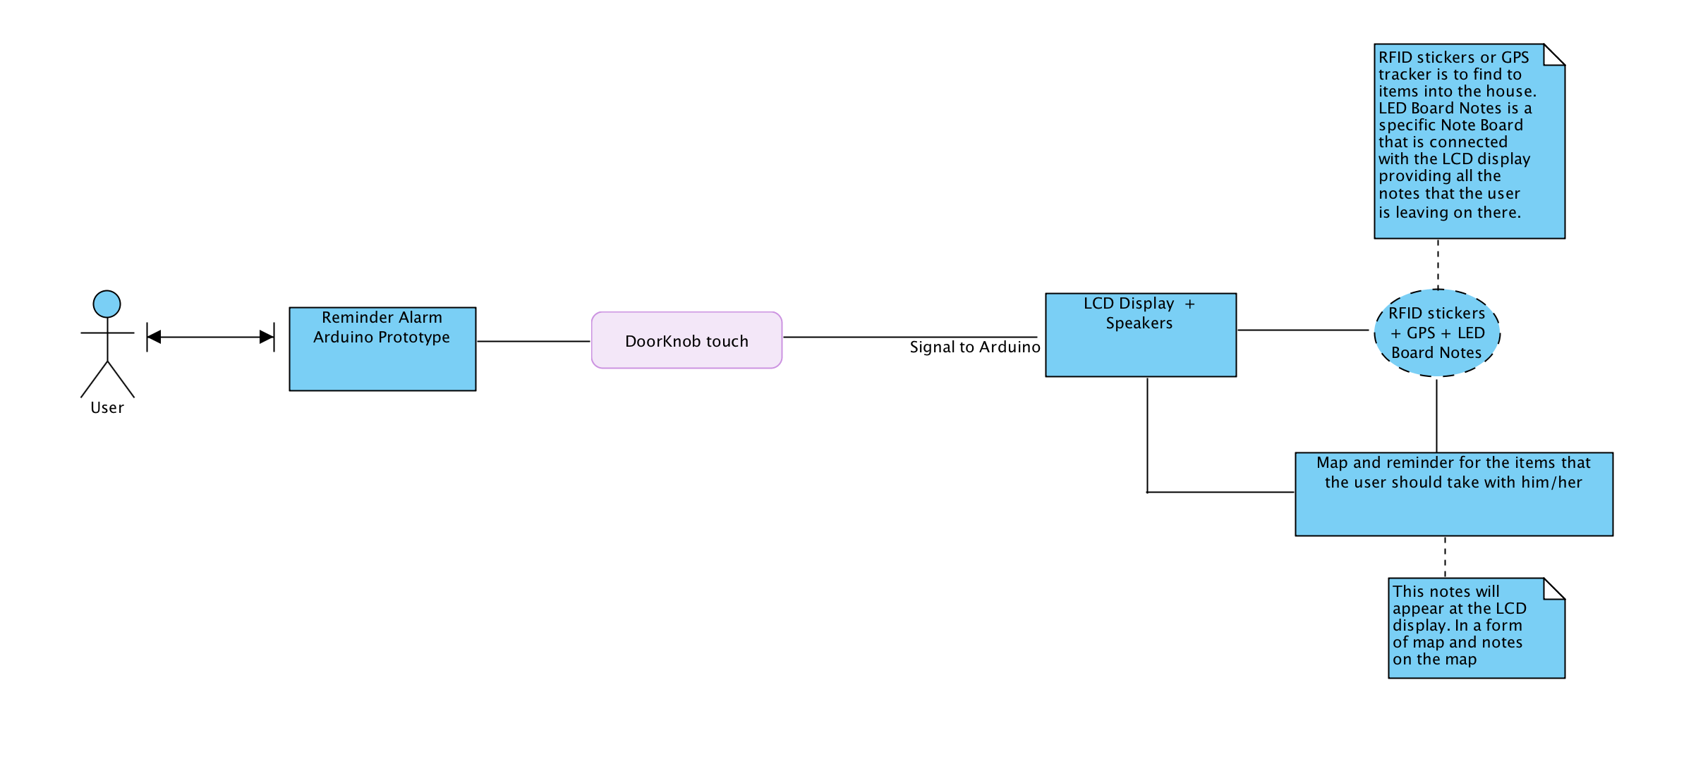

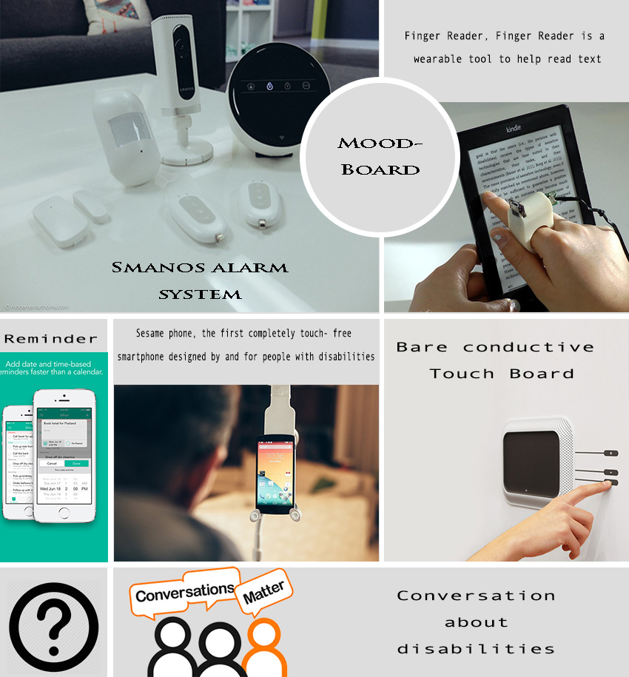

Figure : MoodBoard

The next step was to design the user journey using Visual Paradigm shown in the Figure 2. The image shows what happens when an individual interacts with the product.

Figure : User Journey

Following this, I created my personas and scenarios which would provide more information about my final prototype. As a result I came up with two personas and one scenario.



|  |  |
| --- | --- |
| John Smith | |
| **Occupation:** | Financial Analyst |
| **Demographics:** | * 30 years old * Married * Father of one child (Stefani , aged 2 ) * Has a BA in Business Management |
| **Technology Use:** | Basic knowledge. He uses the computer for work and has an iPhone for personal use. When he gets home, he spends about an hour browsing and playing games online. |
| **Key Goals:** | * Knows that he needs a reminder for lists that he always forgets * Keys/ Wallet/ Charger * Something like mind mapping software and Dictaphone |
| **Description:** | John is anxious , disorganized, can be easily frustrated and clumsy. He likes to be organized but sometimes cannot control the dyspraxia and that’s why his wife helps him with his daily planning. However, he doesn’t like it because he feels that he is depend on others. Using mind mapping software and dictaphone helped him but he lost his Dictaphone as a results he is searching for something that cannot be lost and be connected to his daily routine. Using the doorknob alarm makes him feel safer about his personal plans. |
| **We must not** | * Need charger * Only Vision * Complex System |

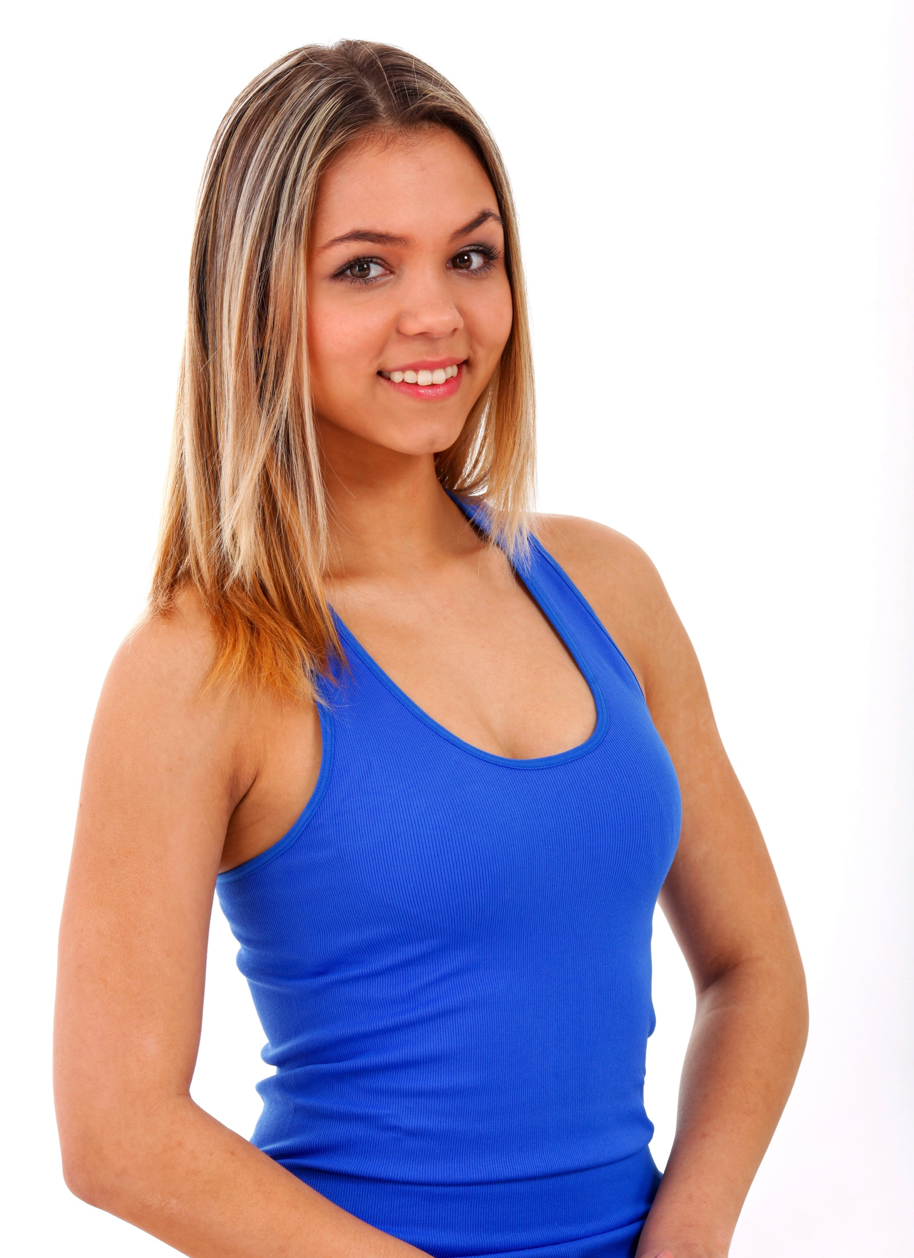

|  |  |
| --- | --- |
| Zoe Smith | |
| **Occupation:** | PhD Student |
| **Demographics:** | * 28 years old * Single * Has a BA in Psychology * Has a MSc in Human Computer Interaction |
| **Technology Use:** | She is doing her PhD on computing combined with psychology as a result her knowledge is really good. She is working for projects about robotic and prototypes. |
| **Key Goals:** | * Knows that she wants to buy * Keys/ Wallet/ Charger * Something like mind mapping software and Dictaphone |
| **Description:** | Zoe has difficulties to focus, disorganized, can be messy and cluttered. She needs to be more organized for the purchase of her PhD degree. Using the doorknob alarm, she feels safe about her daily planning. As a result, she doesn’t have to worry for her important items that she will need during her day |
| **We must not** | * Need charger * Only Vision * Complex System |

## Scenario for Zoe Smith

Zoe is 28 years old, loves computing, loves new technology trends and has really modern house. However, her dyspraxia is frustrated her at her daily things. Doorknob Alarm is helping her before she leaves from her house to take her personal belongings such as wallet, keys, chargers, phone or lists that she wanted to have with her. The most important thing is that it can provide a map and where exactly are the items in the house, giving specific details for the room that she can find them. Another important detail is that the system can read the map and give her the information. As a result, if she doesn’t look at the LCD display she will hear the system telling her about her belongings.

# Final Week and Final Idea

Having completed the previous stages and knowing at this point what would be helpful for dyspraxics, I continued with my first sketches and prototypes. My final idea is a display screen next to an individual’s front door that will be activated after the sensor feels that someone is putting their hand on the door handle, as they are ready to leave. As a result of this action, the LCD display will start-up and show a map of the house where it will illustrate the location of the items, informing them that they forgot one of their important items e.g. keys, wallet, shopping list. Tracking of their possessions will occur via RFID tags, which will provide the exact location to the LCD display. At the bottom of the LCD display, subtitles will appear informing the user and reminding them about their important belongings. Another feature of the device is its ability to read out loud the subtitles presented on the LCD display. This is done automatically, and will start at the same time as the subtitles.

Additionally, the LCD display will inform the user if a list is on the note board. This note board is interactive and will be connected to the system, transferring the data of the shopping list. This product makes sure that dyspraxics have all their important belongings with them before they leave from their home.

To represent this, I drew sketches (Figure 3) and a storyboard (Figure 4).

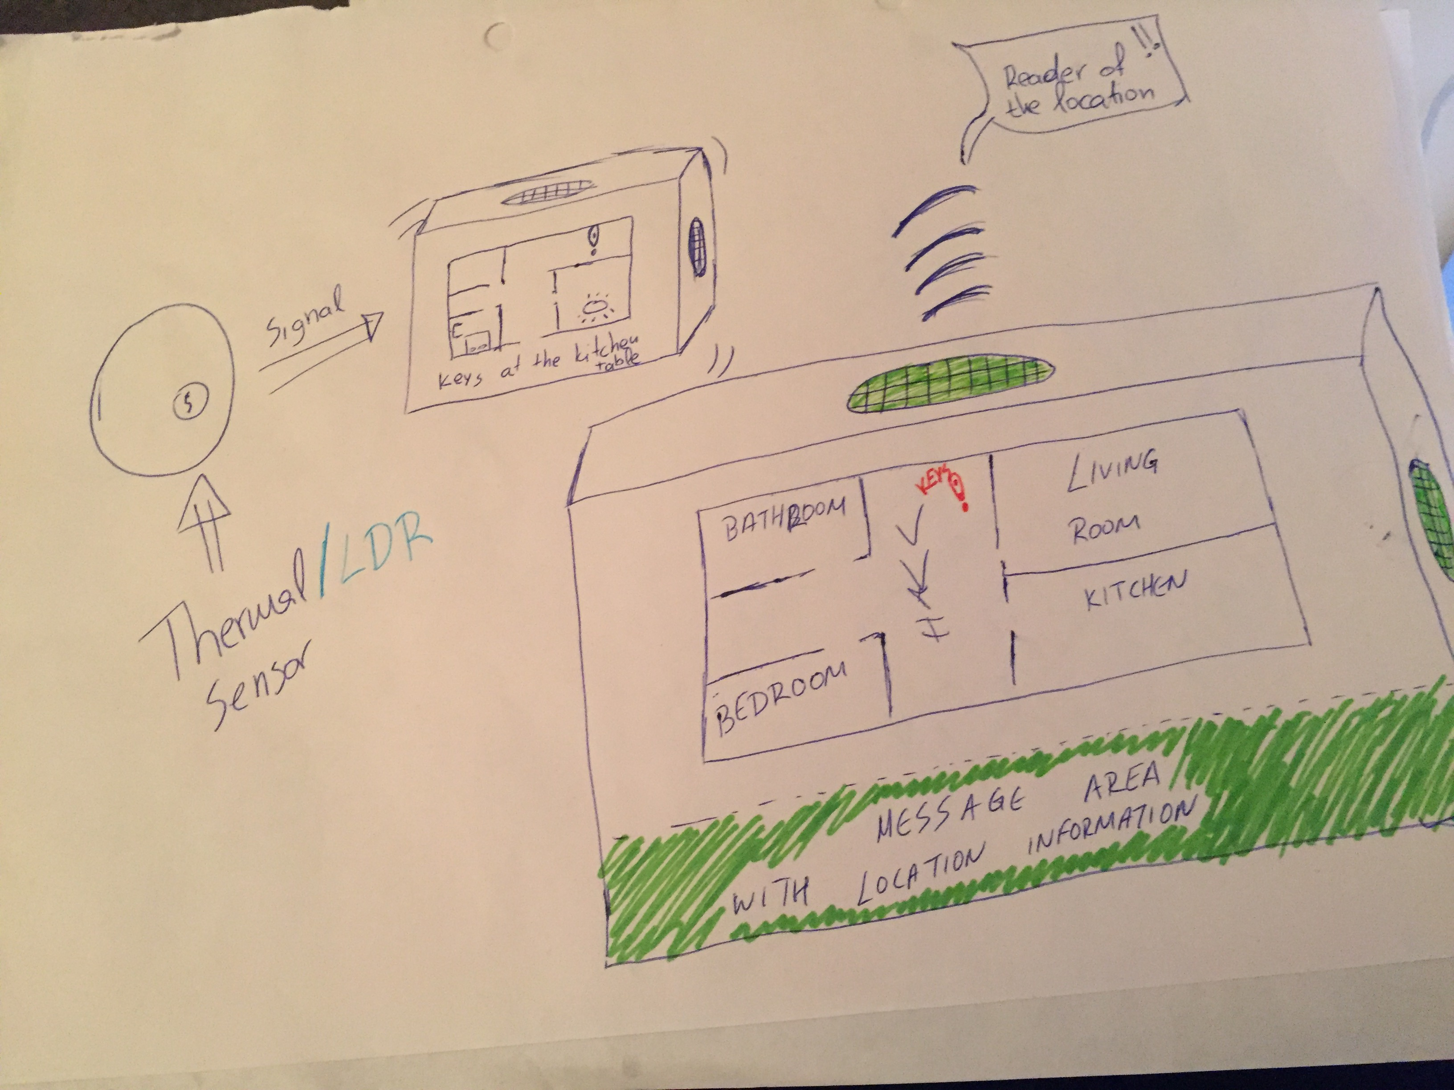

Figure : Product sketches

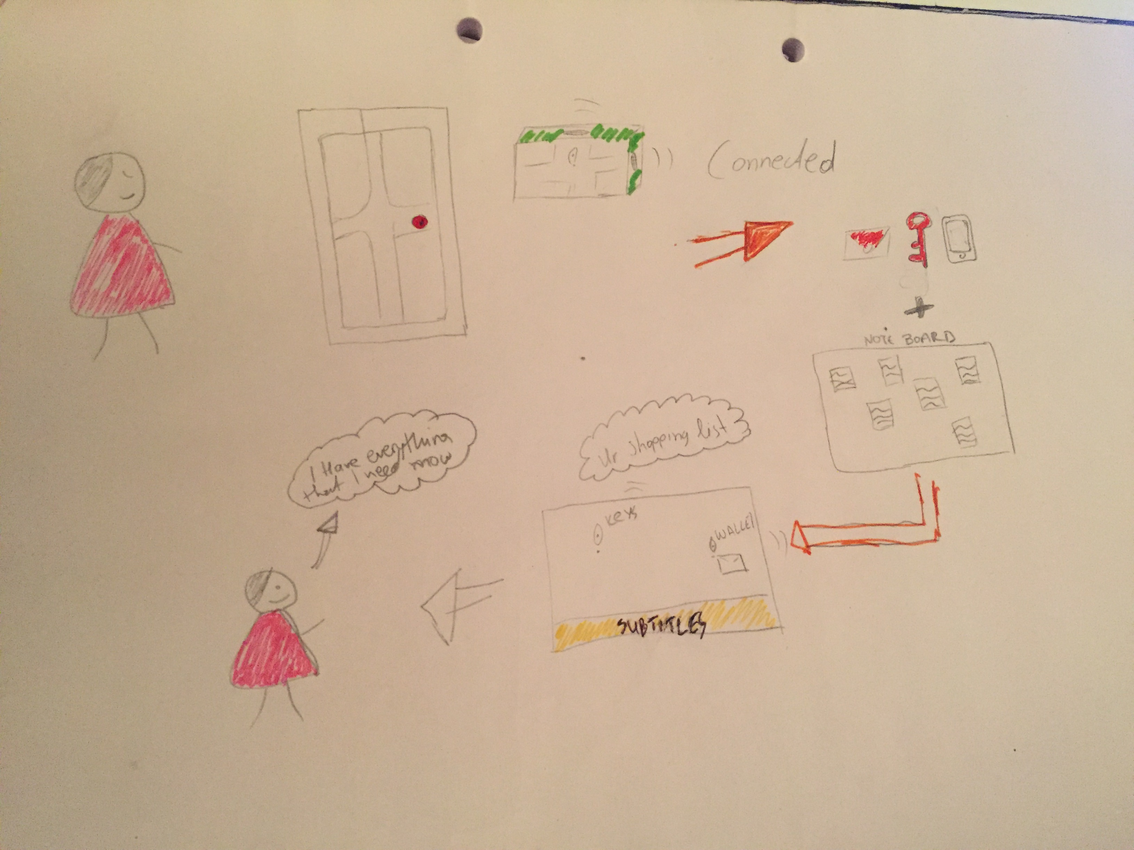

Figure : StoryBoard

## User Experience

The device should be really simple to activate and easy to use. The interface of the screen will show only the house map, which will be installed by the company. Individuals will have to add their fingerprints to the device, as this is how the sensor is activated. The device will ask for fingerprints automatically the first time that users log in for ease, avoiding users having to go through convoluted steps to add their own fingerprints. Another action that the user should do is to add the RFID tags on the belongings that need to be tracked from the device. The note board, in which the device is held on, will be connected to the LCD, and produced by the company and will look like a normal note board. It should be noted that specific instructions would be given to the users in order to explain them about the correct use of the RFID stickers.

The following picture (Figure 5) provides the interface design of the product that I have in my mind.

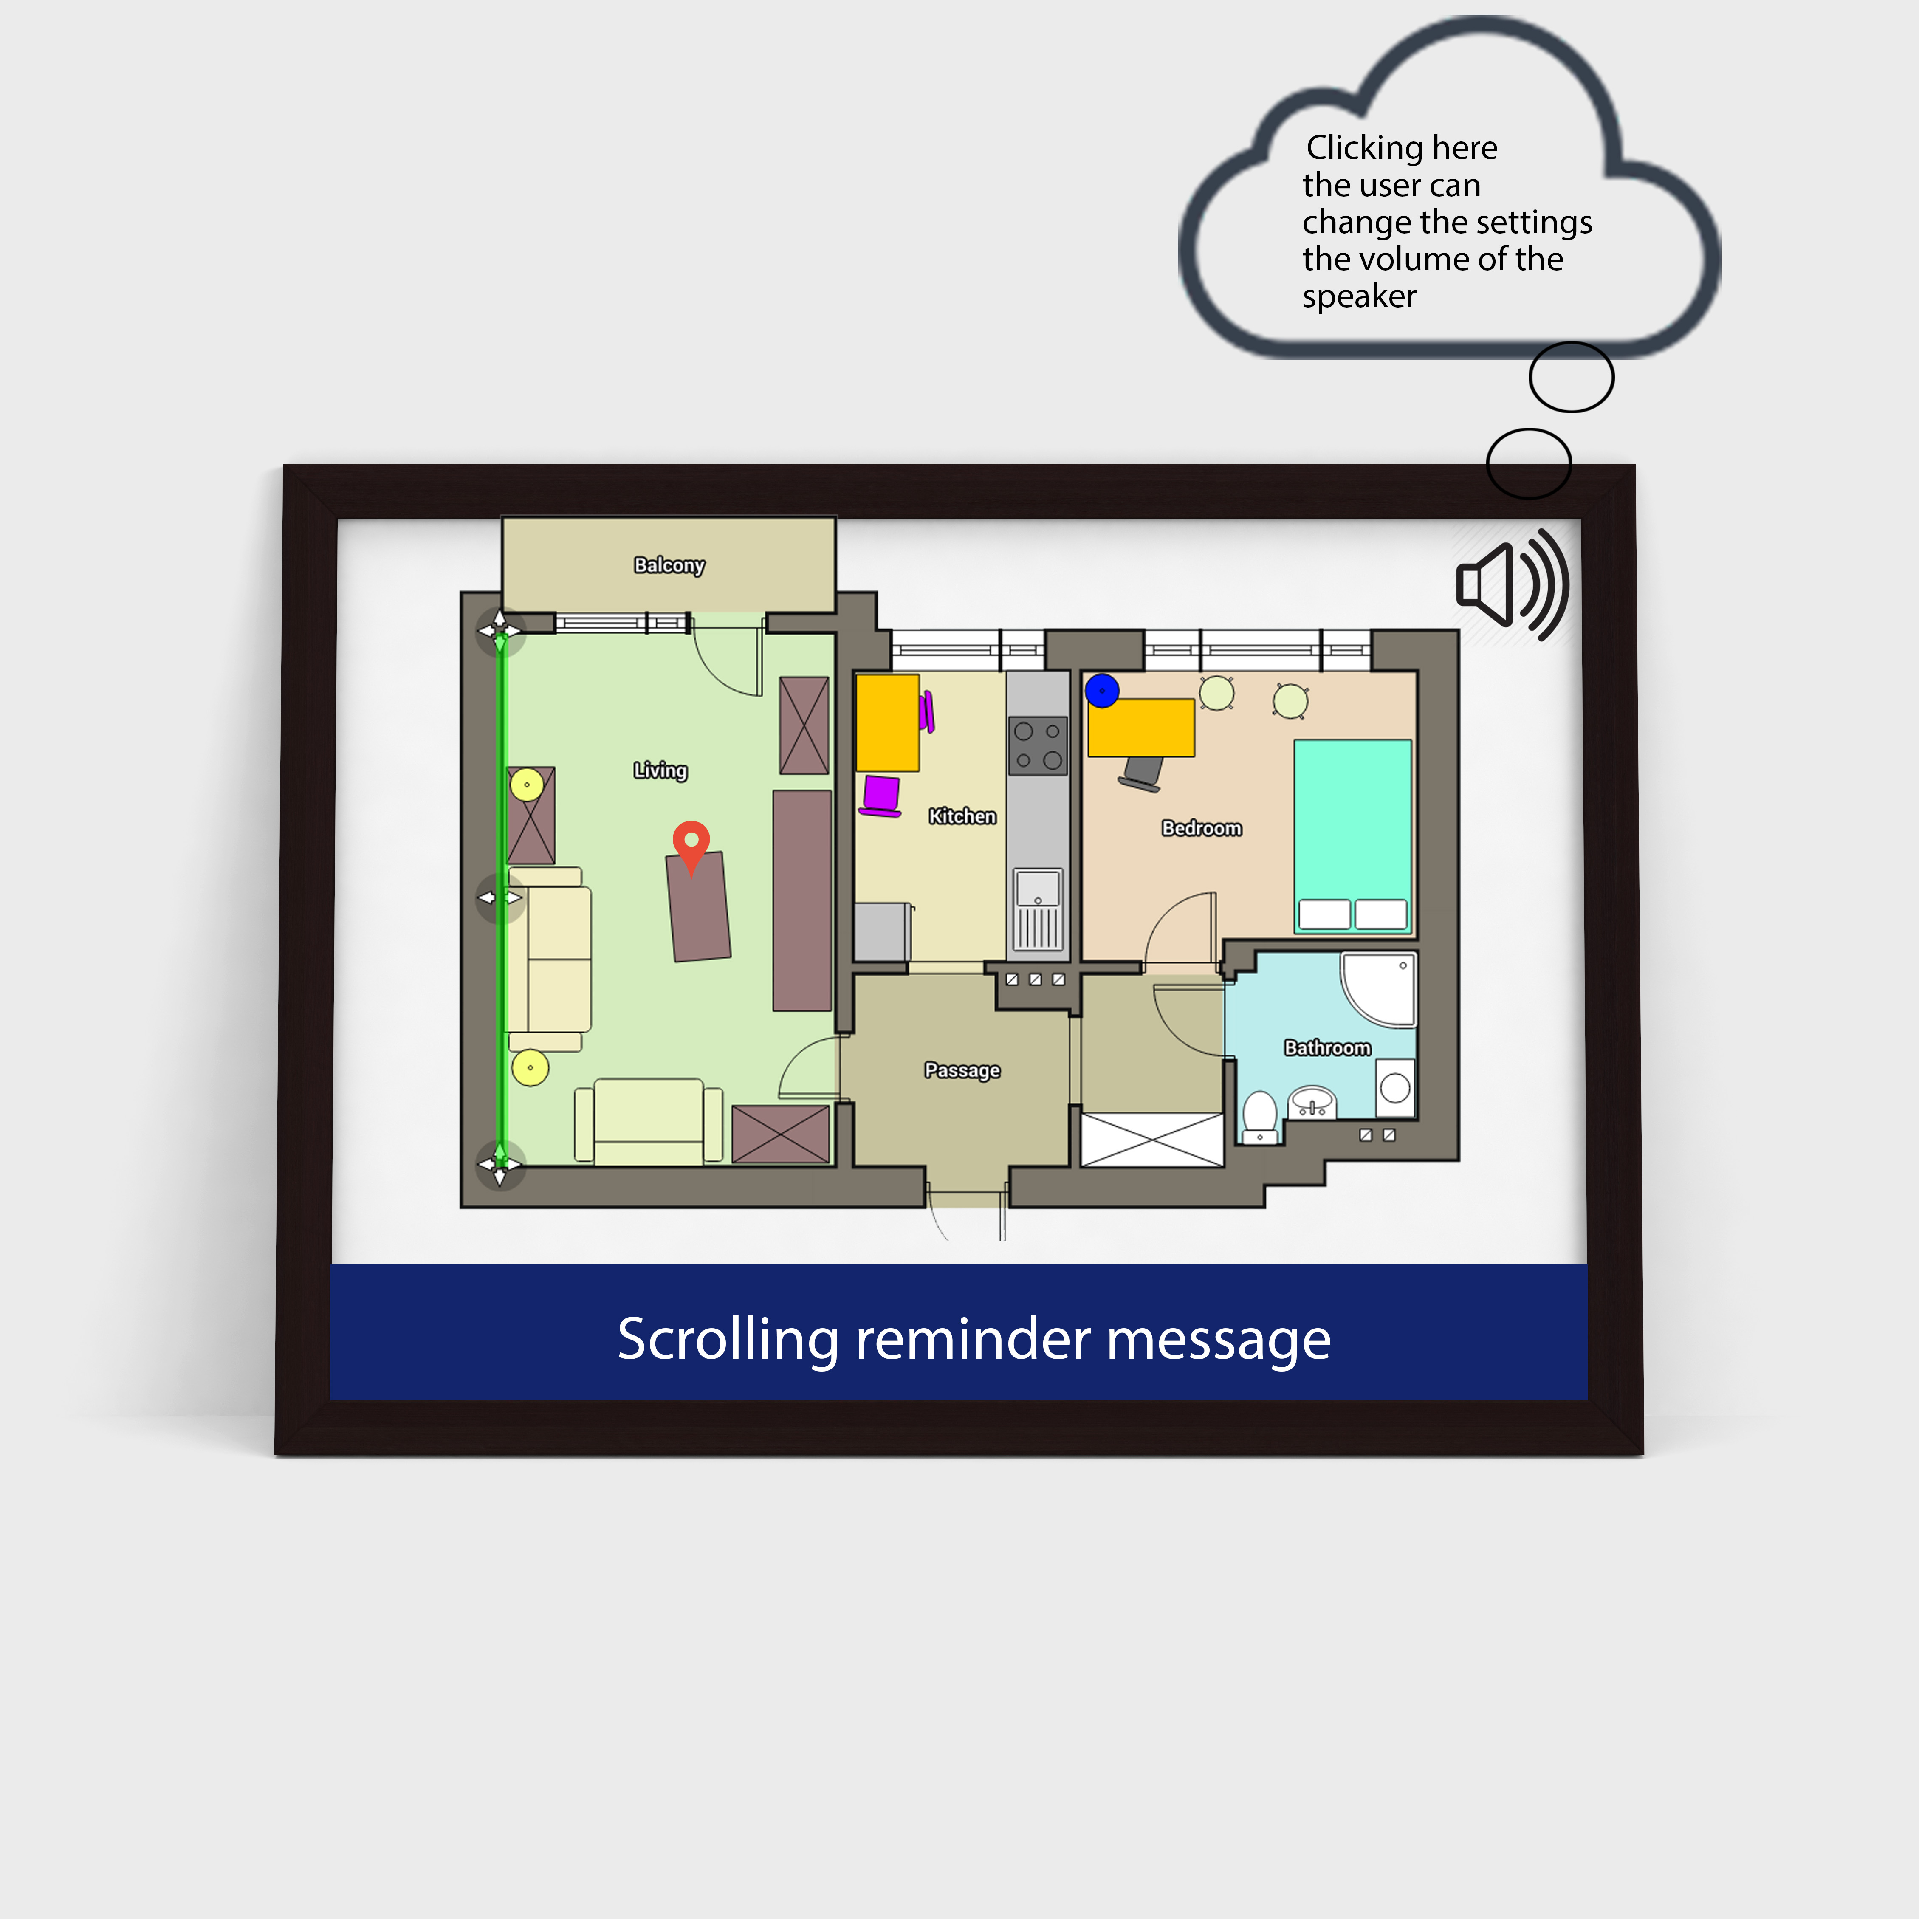

Figure : Interface Design

The red pin gives the location of the item in the house and the sound icon is a button that the users can press if they want to change the level of the volume.

# Arduino Connection

For my prototype I had to connect the light sensor with the LCD display. The Arduino components are represented in Figure 6.

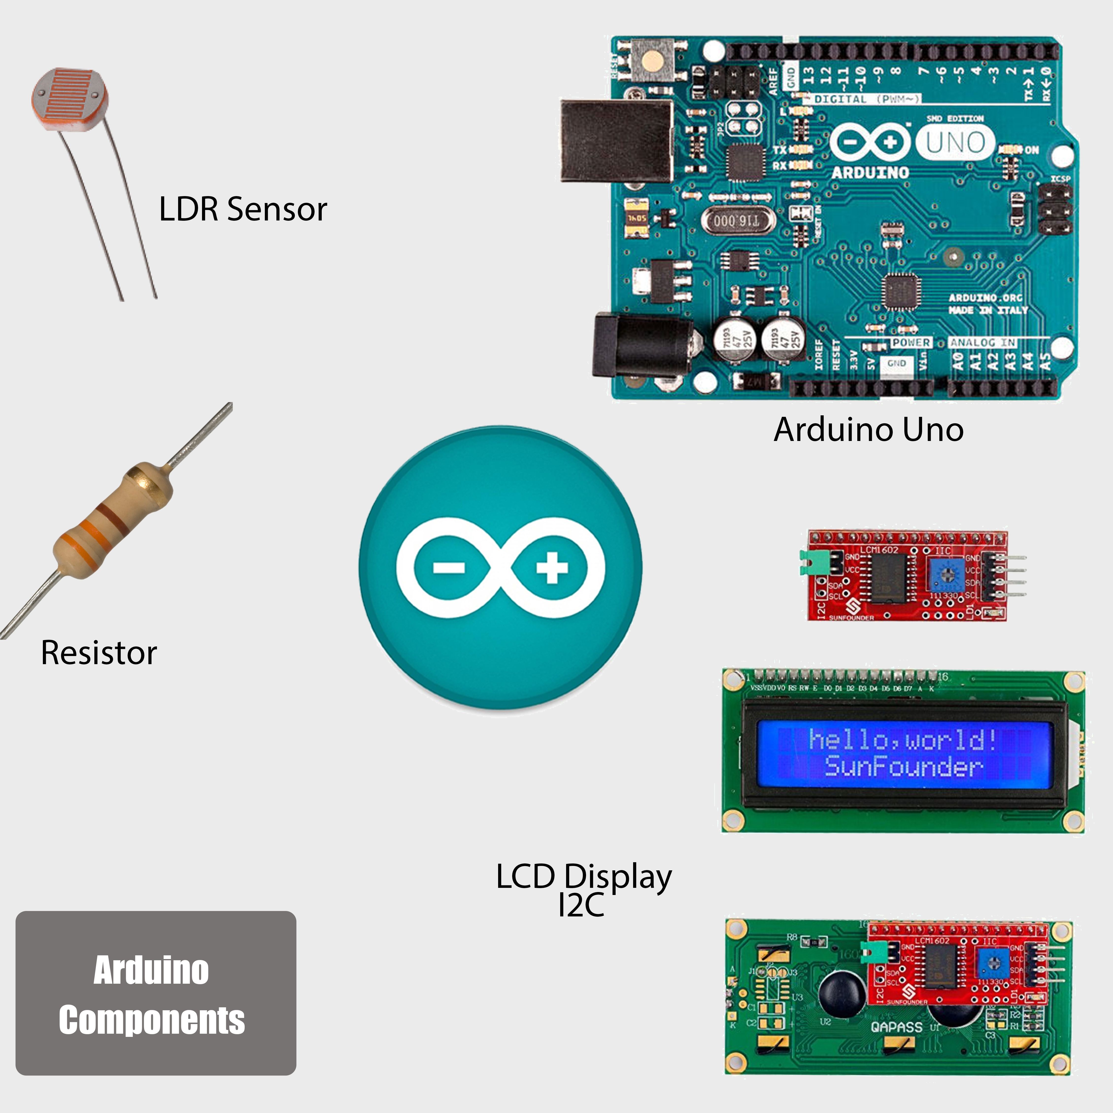

Figure : Arduino used Components

The system will start to show the scrolling message when the individual’s hand is close to/touching the sensor.

The first step in the process was to connect Arduino with the LCD display and as a result the LCD provides the scrolling message as it shown at the Figure 7.

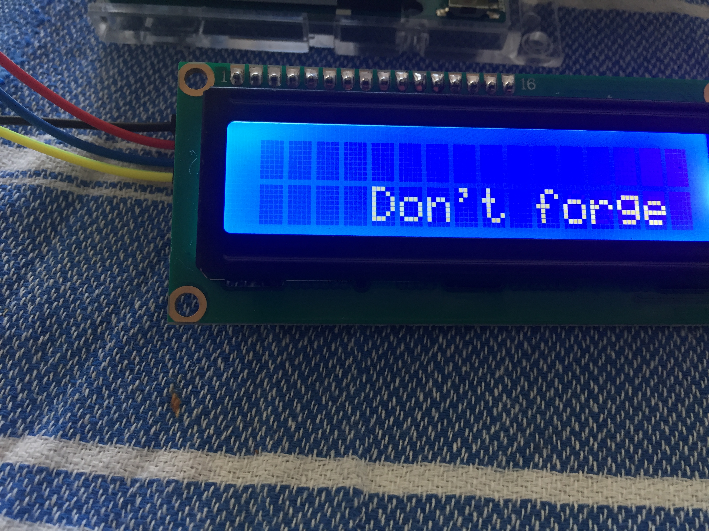

Figure : Arduino message

Next, I added the LDR sensor into the pin C12 and C18 and connected my LCD cables on the breadboard. Activating the LDR sensor, the text starts to scroll and gives the information. However, my prototype doesn’t have RFID stickers yet or the map so I cannot provide the information as it was originally.

The following, Figure 8, shows the interface of my Arduino prototype using the Fritzing open-source hardware.

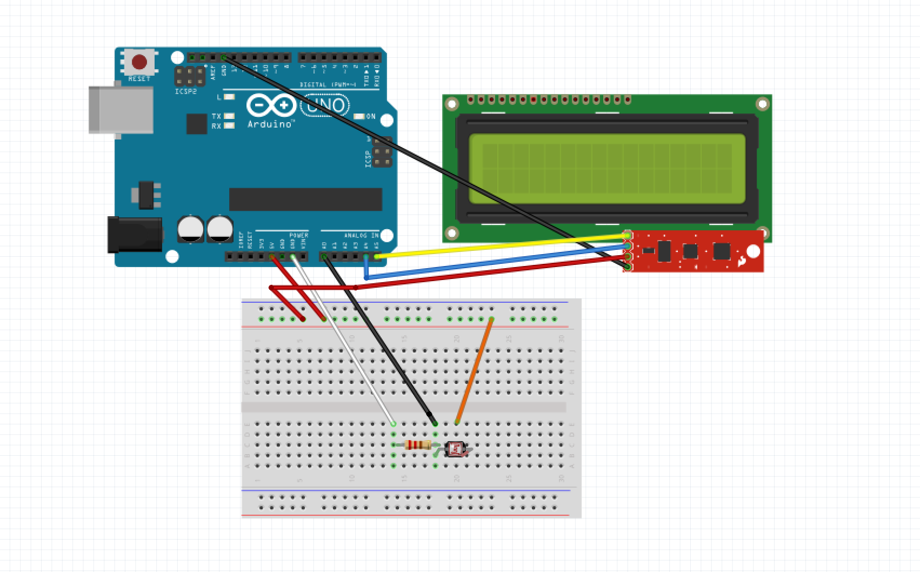

Figure : Interface of my prototype

# The Process of Coding

Coding was the only thing that I was comfortable with from the begging even if I didn’t know exactly how to connect the cables. However, my code for this prototype was simple (from if statements I finalized my prototype). Of course, I needed some guide and Rachel Menzies advised me about Arduino and coding, giving me some components that I could use for my prototype.

# My Conclusion

Originally, this felt like a daunting task, where it seemed almost impossible. Having completed it, I understand Arduino, it’s processes and application as a prototype. I am slightly disappointed in myself for not being able to produce a physical product design using 3D printing as my background is in marketing, e-commerce and user experience. Nevertheless, I gained vast experience in research, design and drawing. I noticed that this module has shaped the way that I am structuring my ideas as now I feel that I have a clearer strategy when developing concepts. I had also previously gained experience in coding; however, it was the first time that I was able to apply coding to produce something physical rather than digital.

In terms of my product, I am pleased to have thought of a novel and innovative idea. There is currently not a lot of support for those with Dyspraxia, other than computer software and implementing strategic skills. It was empowering that I was able to combine both using Arduino.

In the future, there is great scope to develop this product further. There is the possibility to use this in many different areas such as education, where student with dyspraxia may find it useful having a novel way to support them with their needs. In this sense, there is the potential for this to become an assistive technology where it could be produced, marketed and used within education facilities and/or private households.